AERO1005 MATLAB Coursework 2

Author: Liyu MA
Student ID: 20721363
Date of report: 05/06/2026

1.Preliminary Task
Arduino UNO was connected to the computer via USB cable. Communication was established using the Arduino () function in MATLAB. A GitHub repository was created and linked to the MATLAB working folder for version control. The LED blink test was successfully implemented on digital pin D10.

Here is the picture of preliminary task
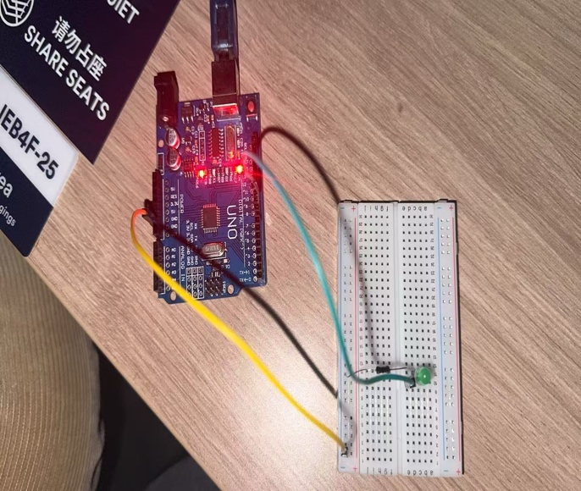

2.Task 1 – Temperature Data Acquisition

a) Hardware Setup
The MCP 9700A temperature sensor was connected to the breadboard with its VDD pin to the 5V power bus, VSS pin to the ground bus, and VOUT pin to Arduino analog channel A0.
Here is the picture of MCP 9700A setup.
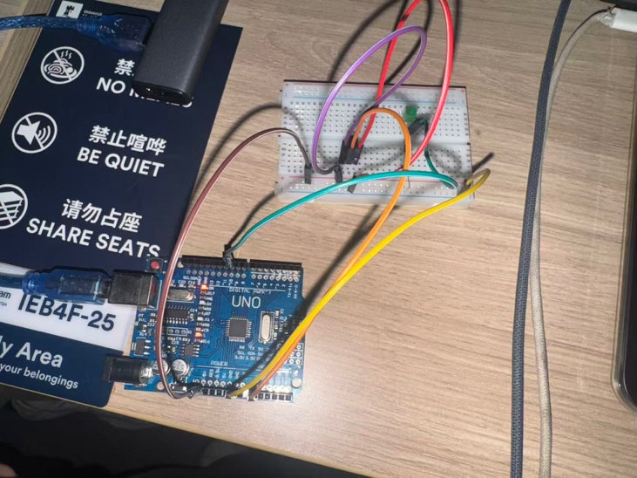
1.2 c)
The picture of temperature plot.
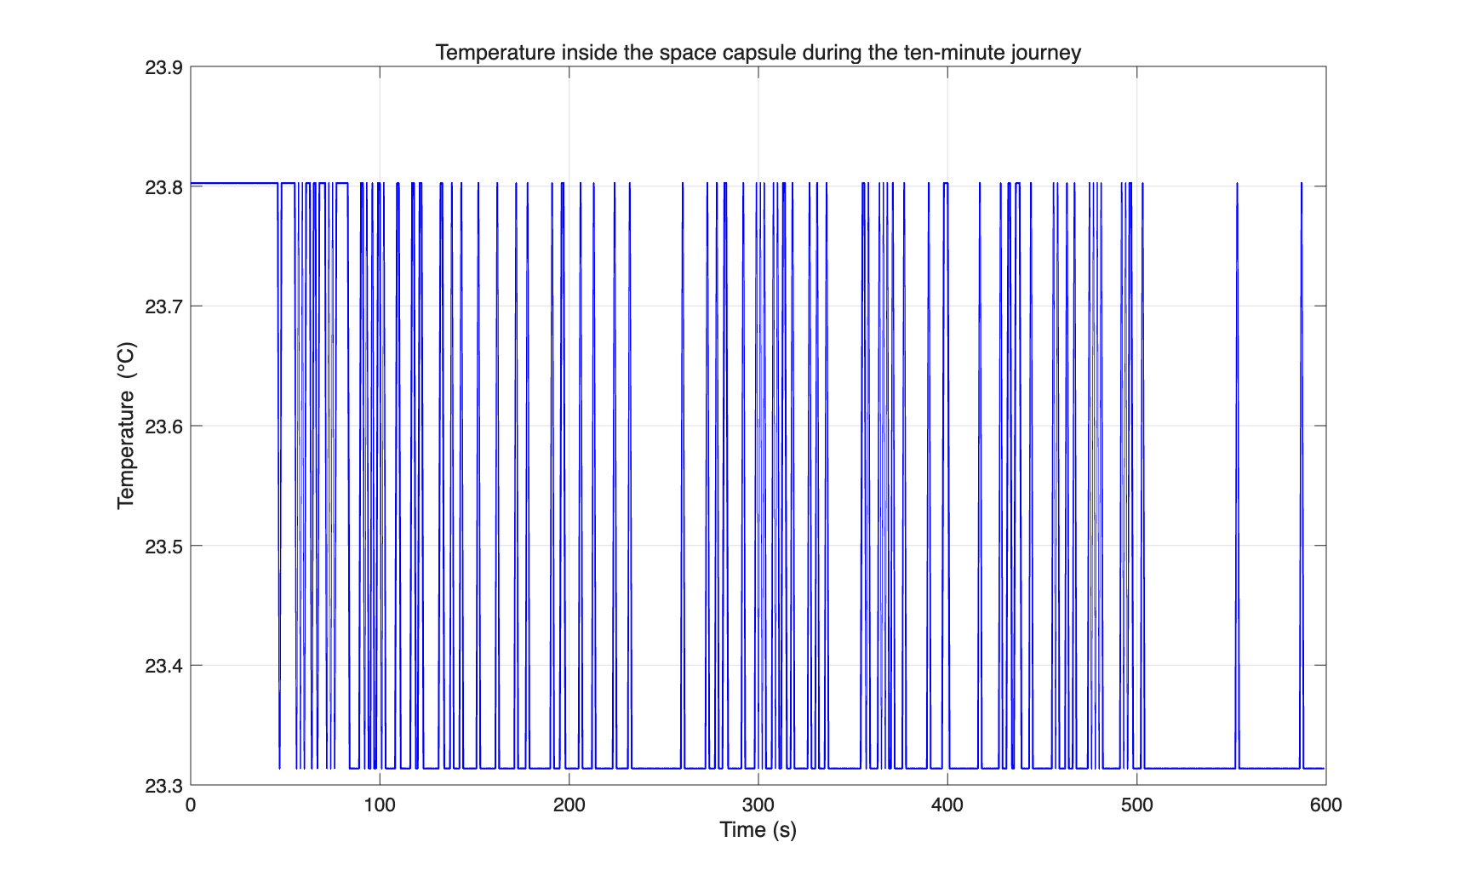

2.Task 2 – LED Temperature Monitoring Device

2.1f) Hardware Setup
Three LEDs (green, yellow, red) were connected to the breadboard. Each LED's anode (long leg) was connected to a digital pin (D10, D7, D4 respectively) via a jumper wire, and each cathode (short leg) was connected to the ground bus through a 220Ω resistor.
Here is the picture of 3_LED setup.

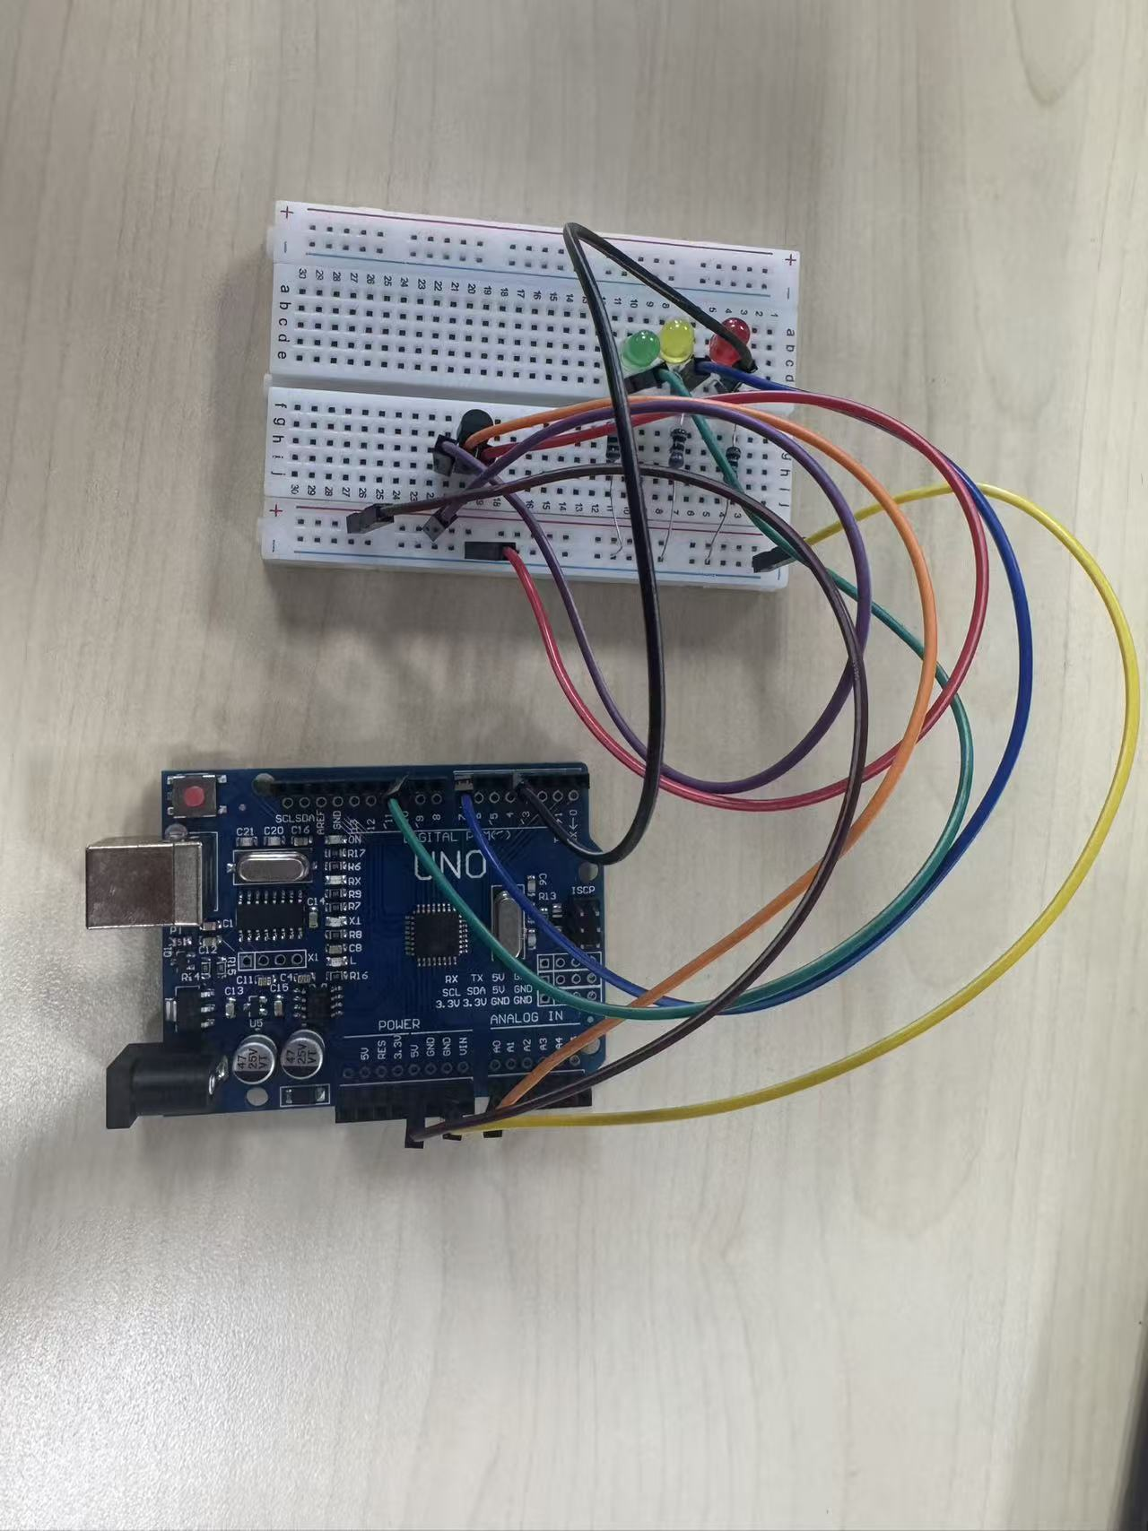

2.2 Pre-Implementation Flowchart

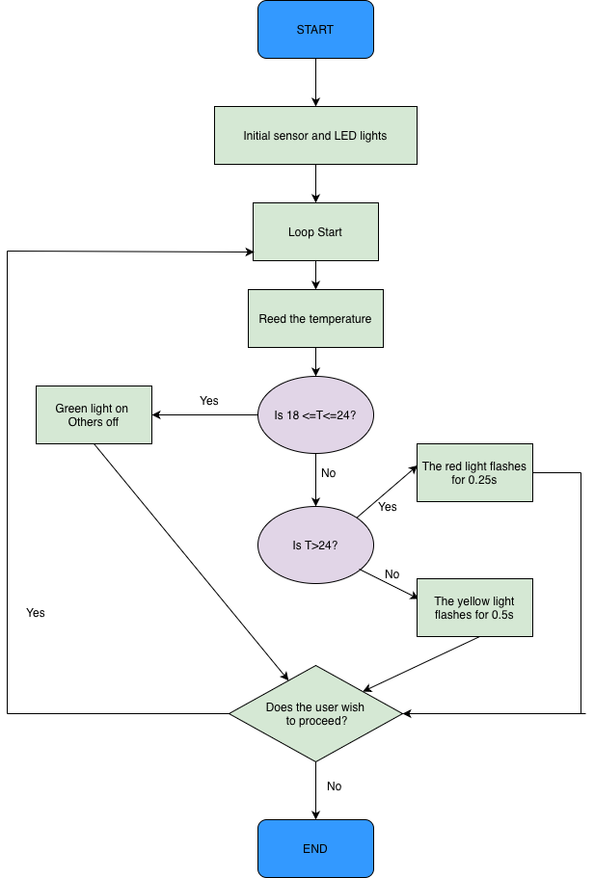

2.3 Post-Implementation Flowchart

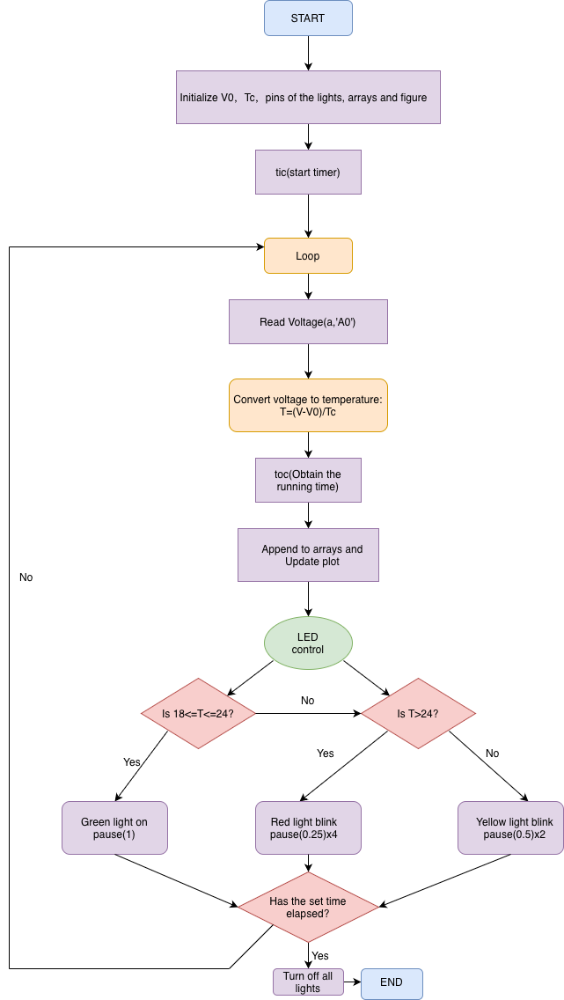

3.Task 3 – Temperature Prediction

3.1Flowchart

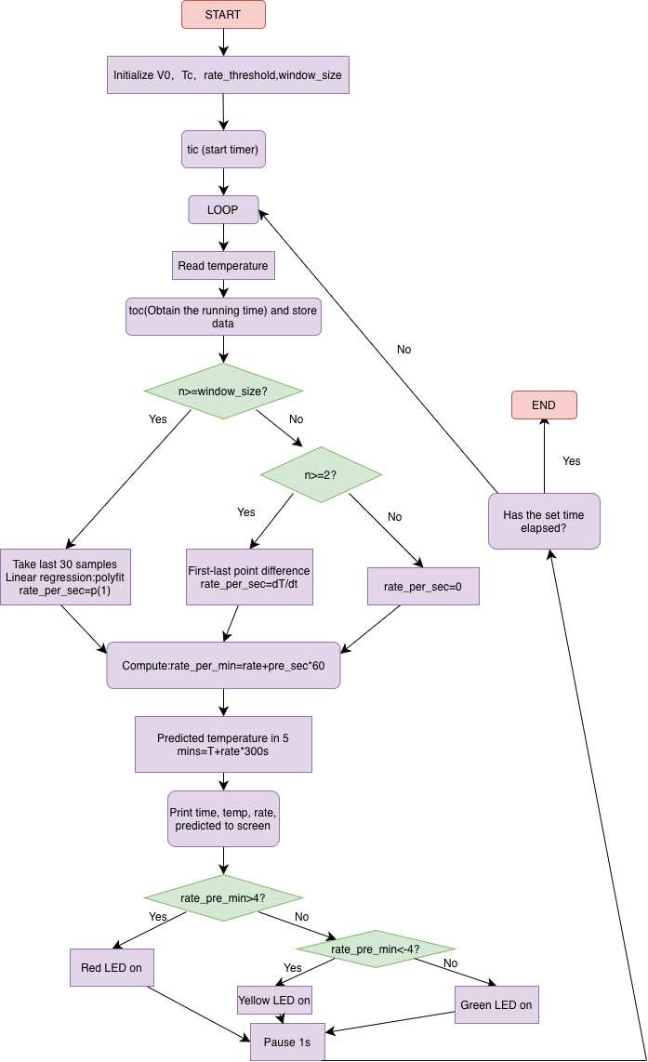

4.Task 4 – Reflective Statement
One of the challenges faced in this coursework was understanding its main purpose and integrating the learned content into programming and practical operations. Another challenge was ensuring that the main program would automatically progress when tasks 2 and 3 were running normally. This issue arose because both tasks 2 and 3 initially used an infinite while true loop, which meant that once task 2 started, task 3 could not be initiated without manual intervention. This problem was resolved in subsequent modifications by setting a running time with while toc <= duration. Finally, great attention to detail was required in the code writing to complete this coursework.
The strength of my coursework lies in the clear separation of the code modular design, data recording, real-time monitoring, and temperature prediction functions. A 30-point sliding window combined with linear regression is used to calculate the rate of temperature change, effectively smoothing out noise and enabling a reasonable prediction of the temperature five minutes later. The LED indication logic is intuitive.
The deficiency lies in that the key parameters such as the comfort temperature threshold (18 °C, 24 °C), rate limit (±4 °C/min), and window size are all hard-coded, resulting in poor flexibility. The prediction model is merely a simple linear extrapolation and does not consider possible nonlinear trends. Therefore, the program cannot reflect the rapid changes in environmental temperature in real time and has certain delays and errors.
Future improvements can be made in the following aspects: Currently, if the temperature threshold needs to be adjusted, it can only be done by modifying the code, which is rather troublesome. These numbers can be changed into input parameters of the function to facilitate modification. The LED remains on when the program is forcibly exited. An automatic light-off function can be added when exiting. In the future, the code can be adjusted to accurately provide feedback to the user even when the environment changes rapidly and the temperature changes unevenly.

